|  |  |  |
| --- | --- | --- |
| **King Saud University**  **College of Computer and Information Sciences**  **Computer Science Department**  **End of Semester Exam (online)**  **CSC304 Computer Ethics and Research Methods** | **Date: 15/9/1443**  **April 27, 2021**  **Time : 9:00 to 10:30** |  |

**Student #: Student name:**

**Marks**

|  |  |  |
| --- | --- | --- |
| **Section** | **Weight** | **Student marks** |
| **Part I**  **“ Case Study”** | **10** |  |
| **Part II**  **“ MSQs”** | **5** |  |
| **Part III**  **“ Term paper”** | **5** |  |

**Part I**

**Case Study**

SASU is a half-meter robot intended to communicate with elderly people. It has speakers, microphones, and build-in cameras. Connection is possible with Bluetooth and WiFi while interactivity is made through an interactive GUI via LabView installed in tablets given to users. The robot can talk, walk, play, share ideas, and advise on different issue and as adequate to the age, culture and locality. It can also investigate the medical and social status of the interacting user and predicts/reacts/advice on treatment and intervention.

With an increase in COVID-19 cases all over our world, SASU company decided to promote use of SASU robot to health authorities, demonstrating its characteristics and benefits. A new version of SASU was advertised to all community members including children and people with disabilities. SASU could be rented as full-time or as a part-time companion in care centers and geriatric hospitals. Kids liked it in the beginning, but it turned out that the robot could not interact as kids-to kids but either kids to an adult or adult to a kid. A few incidents related to kids violence against SASU and over-reactions from the robot were reported. In response to an organized media propaganda, the authority decided to pan use of SASU in-house. The company raised a case at the ethical court claiming that the reported cases were not due to any defect in SASU but on other psychological reflections. They also claimed that it would be better to commit violence on machines than on humans. The case is still under investigation. The court has asked you as an expert in the filed to analyze the case and give your recommendations.

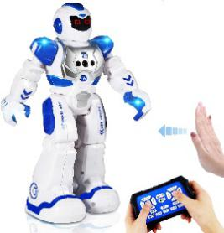 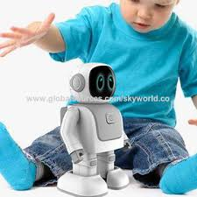 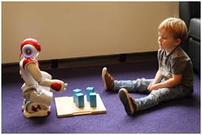

**Part I : Questions on the case study (10 marks)**

1.. Identify **one** of the actions which has led to the conflict

|  |
| --- |
| Action:  the robot could not interact as kids-to kids but either kids to an adult or adult to a kid |

|  |
| --- |
| Conducting party:  SASU and creators |

|  |
| --- |
| Claim of the conducting party  the reported cases were not due to any defect in SASU but on other psychological reflections |

|  |
| --- |
| Your ethical analysis  1.2: avoid harm was violated  1.4 Be fair and take action not to discriminate was violated  2.2 Maintain high standards of professional competence, conduct, and ethical practice was violated  2.5 Give comprehensive and thorough evaluations of computer systems and their impacts, including analysis of possible risks was violated  2.6 Perform work only in areas of competence was violated  2.7 Foster public awareness and understanding of computing, related technologies, and their consequences was violated  3.7 Recognize and take special care of systems that become integrated into the infrastructure of society was violated |

|  |
| --- |
| Your judgement  The company rolled out a system that was made for a specific section of the people to everyone without doing any major work or testing to make sure the product was suitable for other audiences and they should have considered the risks when rolling out the product to an audience that wasn’t originally targeted |

|  |
| --- |
| Your alternative opinion  The company should have waited to roll out or create a new system for the other section of people that they now wanted to market and sell for. They should have tested and fixed SASU so they can interact with the new audience or to create and sell a product that was more suitable for them |

2**. What would be the impacts of using SASU as a caregiver to non-critical COVID 19 patients during their in-house isolation period?**

Depending on the age group and the health status of the person, the robot should act accordingly and SASU is in limited numbers so having them be with people that need help more is better rather than having it be entertainment to someone who isn’t in critical condition or in need of help

3. **Identify another action which fully complies with the ACM code of ethics.**

Action: SASU helping the elderly with their needs and communication

Conducted by: SASU

Complies with 1.1 Contribute to society and to human well-being ACM code of ethics.

**Part II (Multiple choice Questions)**

1. **Conceptual framework in which the research is carried out is known as**
2. Research hypothesis
3. Research design
4. research method
5. all of the above
6. **The priority to start your research is for**
7. Developing your research design
8. Formulating your research problem
9. Formulating your research hypothesis
10. Conducting literature review
11. **How do we judge the importance of research?**
12. By its title
13. By its objectives
14. From the affiliation and funding
15. From genuine citations
16. **The objectives of research determines**
17. Its depth
18. Its importance
19. Its methodology
20. Its impact
21. **Indexing and abstracting research papers depends on**
22. The quality of its title
23. The quality of its abstract
24. Both title and abstract
25. Research method

**Part III Term paper question (5 marks)**

* 1. Write here the title of your term paper

Al ethics

* 1. What are the keywords for your selected topic

Artificial intelligence , Ethics , Ethics of Al

* 1. What are the characteristics of a good quality research title

1. It should predict the content of the research paper
2. It should be interesting to the reader
3. It should reflect the tone of the writing
4. It should contain important keywords that will make it easier to be located during a keyword search
5. It addresses directly or indirectly some real problem in the world
   1. Evaluate here the quality of title of your term paper

|  |  |  |  |  |  |  |
| --- | --- | --- | --- | --- | --- | --- |
| **Title** | **Length** | **No Redundancy** | **Specificity** | **Syntax** | **Key words** | **Total** |
| Al ethics | 1 | 0 | 1 | 1 | 1 | 4 |